**GENERAL STATEMENT:** “In your study of the fundamentals of programming …you will find that most if not ALL programs will have a set of instructions that involves

(a) processing or procedures that have some sort of physical or logical flow

**(control structures aka. constructs)** and

(b) the program may need and/or work with different types of data **(aka. data structures)** “

**Write a program to calculate the average rainfall over a period of days. Problem:** Calculate the average rainfall over a period of days.

**Question:** How would you do this by hand?

See **algorithm** below ….

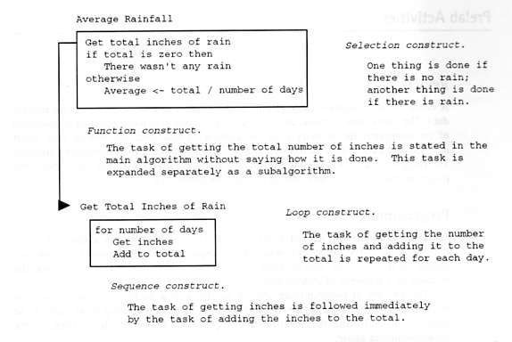

Some things to think about…..

Some questions to ask when it comes to the **control structures** (physical/logical) or flow of your program.. Can you identify the control structures or constructs? What do you think these constructs are set-up to do?

Some questions to ask when it comes to **data structures**…

Can you identify the kinds of data or values this program will need and/or uses? Is the data type alpha or numeric?

If the data type is numeric …should the values be integers (whole numbers) or float (real

numbers)?

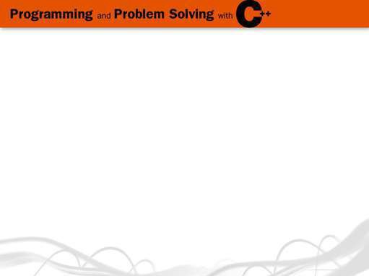

C++ Data Types C++ Simple Data Types



**simple structured**

**simple types**

**integral enum**

**char short int long bool**

**floating array struct union class**

**integral floating**

**char short int long bool enum float double long double**

**float double long double address**

**pointer reference**

**unsigned**

15 16

Completed source code demonstrated using wxDev C++ ….. Source code file rain.cpp

Data file data.in

DO NOT WORRY …if you no idea what the source code means?

In the following weeks we will you will be introduced to both the following:

(1) Programming Topics (control structures and data structures)

and

(2) C++ language syntax and semantics (write, test, debug and solve problems using program code)

**ONE FINAL COMMENT….**

**“The Gaddis textbook will progress from procedural programming (Chapters 1- 9) into the world of object oriented programming (Chapter 12)”**